Name:

Homeroom:

Subject Teacher:

Year 11

Unit 2 Economics Examination

Semester Two, 2018

Reading Time: 10 Minutes

Writing Time: 90 Minutes

|  |  |  |  |
| --- | --- | --- | --- |
| **Section** | **Number of Questions** | **No. of Questions to be answered** | **Number of Marks** |
| Section A: Multiple Choice | 25 | 25 | 25 marks |
| Section B: Growth & Sustainability | 3 | 3 | 21 marks |
| Section C: Efficiency & Equity | 4 | 4 | 25 marks |
| Section D: Globalisation | 2 | 2 | 10 marks |
|  |  | Total: | 80 marks |

|  |
| --- |
| /80 |

**Specific Subject Instructions:**

* Attempt all questions.

**Materials Allowed:**

* Pens, pencils, sharpener, eraser, highlighters and a ruler

|  |
| --- |
| Students are NOT permitted to bring mobile phones and / or any other electronic communication devices into the examination room. |

**SECTION A: MULTIPLE CHOICE (20 MARKS)**

**Question 1**

**Which of the following is not an injection into the circular flow of income?**

A. Investment

B. Exports

C. Savings

D. Government spending

**Use the following information to answer questions 2 and 3**

This scenario describes the total economic activity occurring in an economy: In Year 1, a dairy farmer produces milk, which she sells to the dairy processor for $100. The processor creates cheese, which she then sells for $200 to the retailer. The retailer sells the cheese to consumers for $400. In Year 2, assume that economic activity remains the same, except that the retailer now sells the cheese to consumers for $500.

**Question 2**

**Which of the following statements is false?**

A. The total value of production in Year 1 is $400

B. Gross National Income for the economy in Year 1 is $400

C. Real Gross Domestic Product for the economy in Year 1 is $400

D. Nominal Gross Domestic Product for the economy in Year 1 is $700

**Question 3**

**Identify the false statement from those below:**

A. The total value of production in Year 2 is $500

B. Real Gross Domestic Product for the economy in Year 2 is $500

C. Nominal Gross Domestic Product for the economy in Year 2 is $500

D. The growth rate of real GDP has been zero

**Question 4**

**Which of the following combinations are all examples of factors affecting aggregate supply?**

A. Productivity, costs of production, business confidence

B. Productivity, costs of production, interest rates

C. Consumer confidence, cost of inputs, climatic conditions

D. Business confidence, wage growth, company tax rates

**Question 5**

**If Australia was experiencing very low rates of economic growth (a downturn), it is likely**

A. the government would decrease budget spending and/or increase taxes, and the RBA would decrease the cash rate (interest rates).

B. the government would increase budget spending and/or cut taxes and the RBA would increase the cash rate (interest rates).

C. the government would decrease budget spending and/or increase taxes and the RBA would increase the cash rate (interest rates).

D. the government would increase budget spending and/or cut taxes, and the RBA would decrease the cash rate (interest rates).

**Question 6**

**Which of the following is not considered a factor contributing to economic globalisation?**

A. The desire of large businesses to take advantage of improved economies of scale

B. Improvements in transportation technologies, information technology and global communications

C. Recent decisions by some governments to restrict the flow of labour and trade, and favour local producers

D. Savings offered by differentials in wage rates across different countries

**Question 7**

**All of the following examples are likely to contribute to more environmentally sustainable economic growth, apart from**

A. households installing solar panels on their rooves.

B. government legislation to reduce the number of fishing licenses on issue.

C. introduction of a tax on carbon emissions.

D. government subsidies to coal-fired electricity generation.

**Question 8**

**In relation to the Lorenz curves shown in the diagram below, which of the following statements is false?**

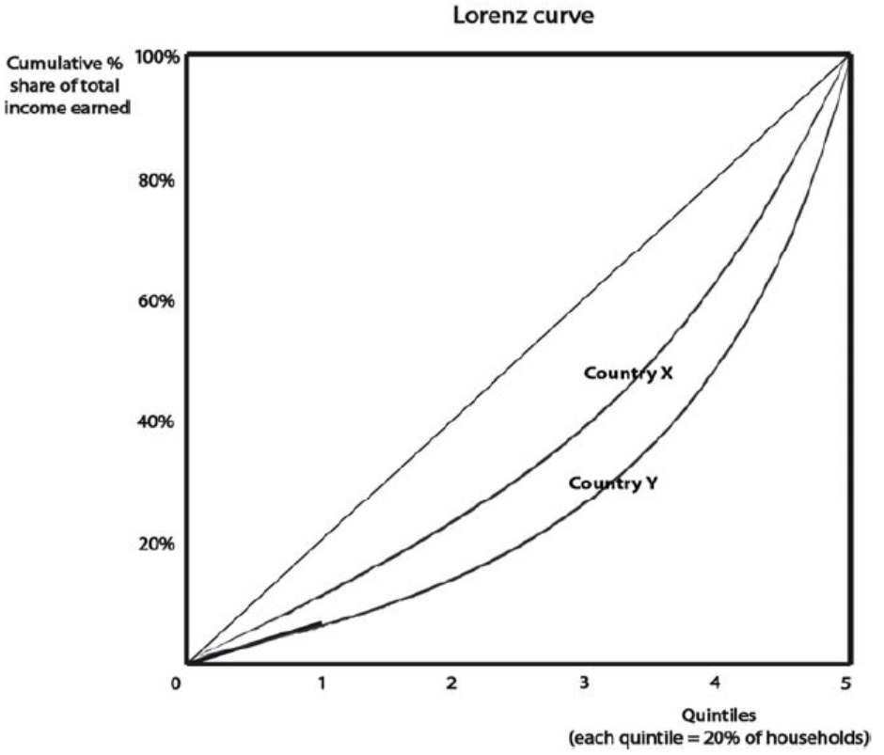

A. Country Y is likely to have a larger Gini coefficient than Country X

B. Country X is likely to have a more unequal distribution of wealth than Country Y

C. Country X has a more equal distribution of income than Country Y

D. Country X is likely to have a more progressive income tax system than Country Y

**Question 9**

**Which of the following factors is most likely to worsen equity in the distribution of equivalised household disposable income?**

A. The government introduces a tax on inheritances of over $1 million

B. The government increases funding for training for young, homeless people

C. The unemployment rate rises from 5.6% to 7%

D. The government removes excises (indirect taxes) on alcohol and petrol

**Question 10**

**Assume that the government reduced the top marginal income tax rate and increased the**

**GST rate. Which of the following would not be considered a benefit of such a policy?**

A. Increased tax receipts from all households, regardless of income

B. Increased productive efficiency due to rising productivity

C. Improved incentives for those on higher incomes to work harder

D. The ‘trickle down’ effect as businesses and wealthy individuals take more entrepreneurial risks

**Question 11**

**If economic growth is negative, overall living standards may still increase if**

A. nominal GDP per capita falls

B. there is increased access to health and education services

C. there is increased levels of pollution and environmental damage

D. population decreases by the same amount as economic growth

**Question 12**

**Of the following events, which is not likely to cause an increase in the aggregate demand for goods and services?**

A. A decrease in the value of the Australian dollar (depreciation of the exchange rate)

B. A decrease in interest rates

C. A decrease in income tax rates

D. A decrease in consumer confidence

**Question 13**

**The main cause of income inequality is**

A. Low income earners not receiving enough transfer income

B. Government provision of social welfare payments leading to people not working hard enough

C. Luck

D. Higher income earners having skills that get them higher paid jobs

**Question 14**

**Disposable income is defined as**

A. Private or market incomes plus direct cash benefits received from governments

B. Gross income less direct taxes plus indirect government benefits provided in the form of goods and social services

C. Gross income less the direct taxes levied by governments

D. Gross incomes less direct and indirect taxes plus indirect government benefits

**Question 15**

**The rate of economic growth in Australia is likely to fall in response to**

A. Higher commodity prices

B. A reduction in interest rates

C. A depreciation of the Australian dollar exchange rate

D. A reduction in the rate of economic growth in China

**Question 16**

**Which of the following is most likely to indicate an improvement in material living**

**standards?**

A. increased incidence of crime

B. increased carbon emissions per capita

C. increased real GDP per capita

D. increased nominal wages

**Question 17**

**An equitable distribution of income refers to**

A. each member of the economy receiving an equal share of total income

B. the way in which income is shared among the members of an economy

C. a distribution of income that allows everyone to receive sufficient income for a dignified life

D. the elimination of relative poverty

**Question 18**

**Examine the two D/S diagrams demonstrating different types of labour markets and choose the most correct statement.**

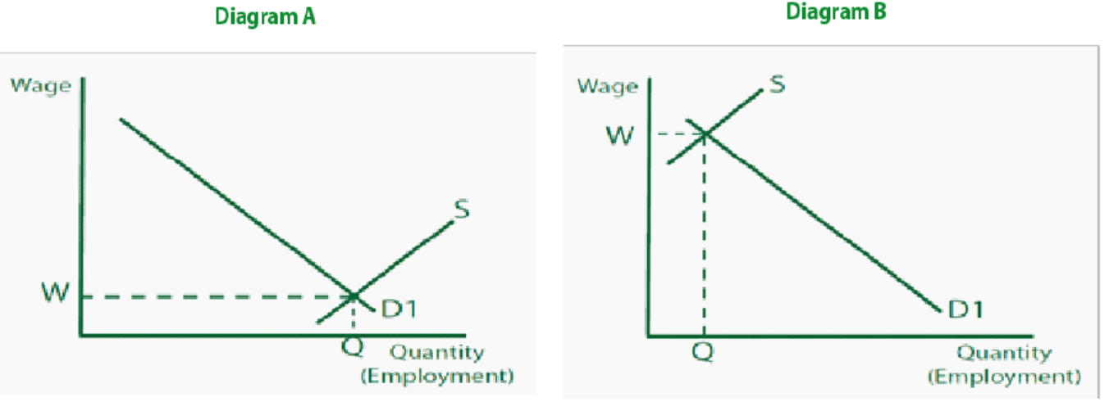

A. Diagram A shows a labour market where the supply of labour is low relative to demand, leading to low wages

B. Diagram A shows a labour market where the supply of labour is high relative to demand, leading to low wages

C. Diagram B shows a labour market where demand for labour is high relative to supply, leading to low wages

D. Diagram B shows a labour market where supply of labour is high relative to demand, leading to high wages

**Question 19**

**If Fairwork Australia were to reduce the minimum wage significantly, which of the following is the most likely result?**

A. A lower Gini coefficient

B. A movement outwards of the Lorenz curve

C. A more equal distribution of income

D. A decrease in absolute poverty

**Question 20**

**In relation to the Australian economy during 2017, which of the following statements is most accurate?**

A. Economic growth has been above 3%, inflation has been below 3% and the Australian dollar has ranged between 0.70USD and 0.80USD

B. Economic growth has been below 3%, inflation has been above 3% and the Australian dollar has ranged between 0.75USD and 0.85USD

C. Economic growth has been below 3%, inflation has been below 3% and the Australian dollar has ranged between 0.70USD and 0.80USD

D. Economic growth has been above 3%, inflation has been above 3% and the Australian dollar has ranged between 0.75USD and 0.85USD

**END OF SECTION A**

**SECTION B: SHORT ANSWER – ECONOMIC GROWTH & SUSTAINABILITY (20 MARKS)**

***Question 1 (9 marks)***

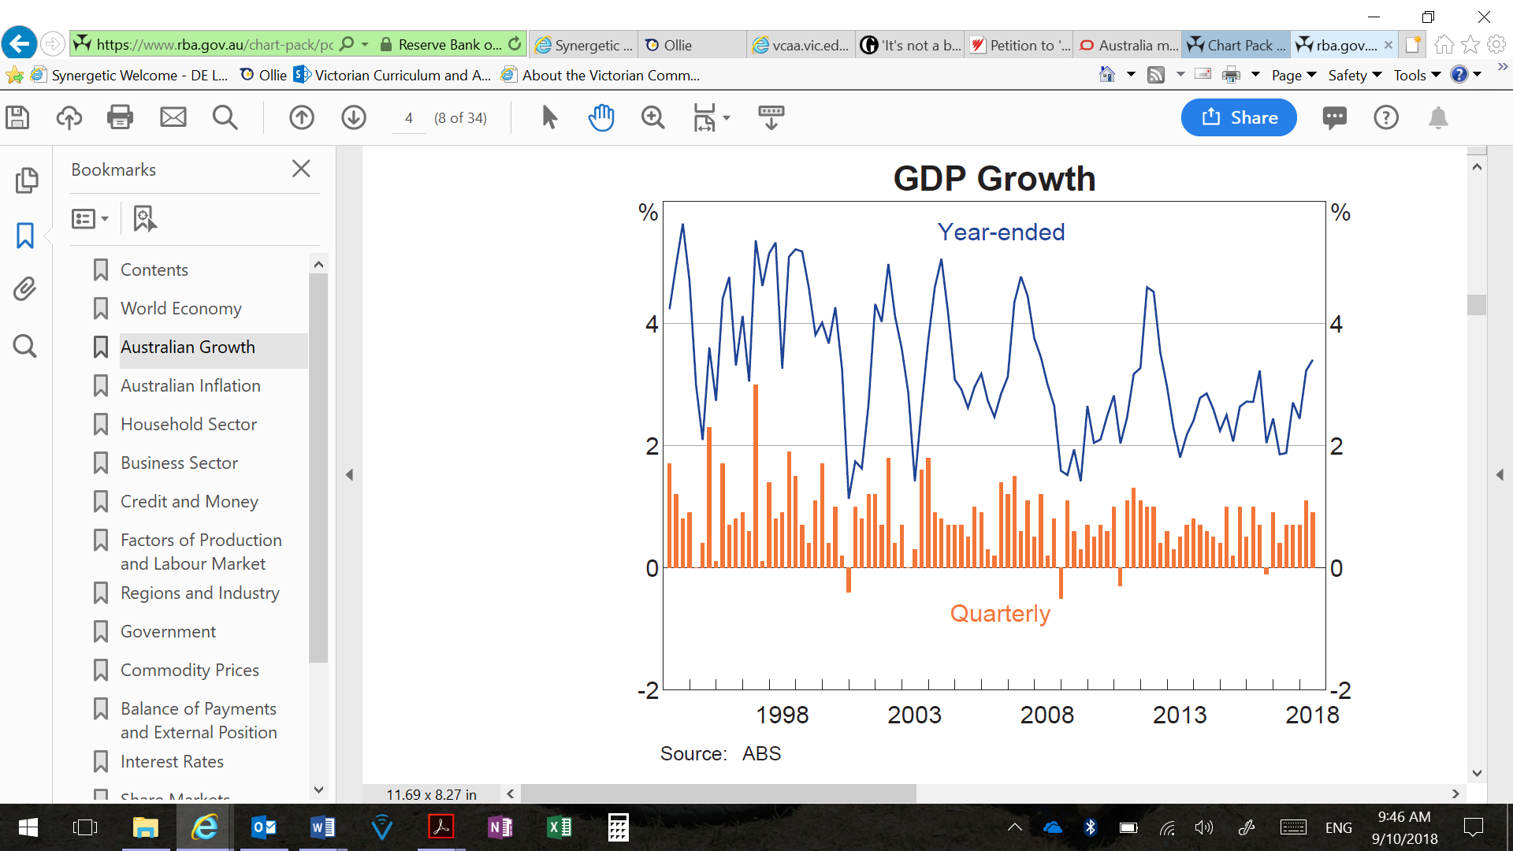

**a.** Define economic growth and describe the overall trend in annual economic growth between the years 2017 – 2018. 2 marks

_________________________________________________________________________________

_________________________________________________________________________________

_________________________________________________________________________________

_________________________________________________________________________________

_________________________________________________________________________________

_________________________________________________________________________________

_________________________________________________________________________________

_________________________________________________________________________________

**b**. Explain how the use of Monetary Policy has increased economic growth in 2018. 4 marks

_________________________________________________________________________________

_________________________________________________________________________________

_________________________________________________________________________________

_________________________________________________________________________________

_________________________________________________________________________________

_________________________________________________________________________________

_________________________________________________________________________________

_________________________________________________________________________________

_________________________________________________________________________________

_________________________________________________________________________________

_________________________________________________________________________________

**c.** Explain why growth in real GDP per capita is used to measure improvements in material living standards and use data from Table 2 to respond to the claim that material living standards in Australia improved between 2013 and 2017. 3 marks

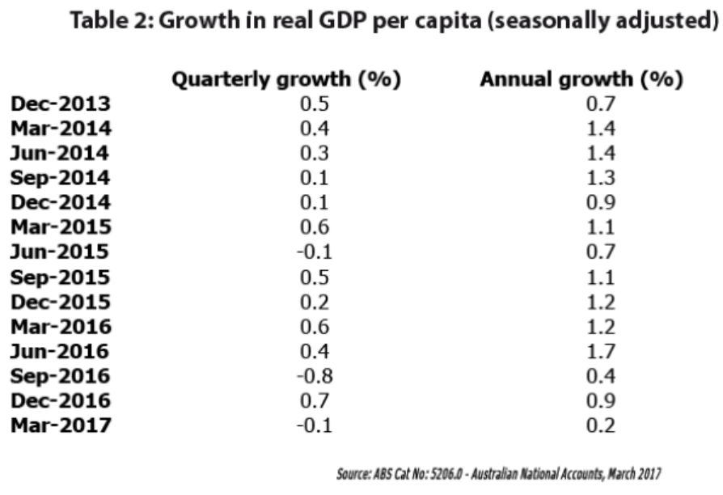

_________________________________________________________________________________

_________________________________________________________________________________

_________________________________________________________________________________

_________________________________________________________________________________

_________________________________________________________________________________

_________________________________________________________________________________

_________________________________________________________________________________

_________________________________________________________________________________

_________________________________________________________________________________

_________________________________________________________________________________

_________________________________________________________________________________

***Question 2 (6 marks)***

Describe how the rate of economic growth is likely to be affected by each of the following economic events.

**a.** An increase in the Medicare levy from 2% to 2.5%, as proposed in Budget 2017/18. 2 marks

_________________________________________________________________________________

_________________________________________________________________________________

_________________________________________________________________________________

_________________________________________________________________________________

_________________________________________________________________________________

_________________________________________________________________________________

_________________________________________________________________________________

**b.** Appreciation of the Australian dollar exchange rate from 0.73USD in January to 0.79USD in August 2017. 2 marks

_________________________________________________________________________________

_________________________________________________________________________________

_________________________________________________________________________________

_________________________________________________________________________________

_________________________________________________________________________________

_________________________________________________________________________________

_________________________________________________________________________________

**c.** An increase in the cash rate from 1.5% to 2%. 2 marks

_________________________________________________________________________________

_________________________________________________________________________________

_________________________________________________________________________________

_________________________________________________________________________________

_________________________________________________________________________________

_________________________________________________________________________________

_________________________________________________________________________________

_________________________________________________________________________________

***Question 3 (5 marks)***

The South Australian Government has a target that 50 per cent of the state’s energy will be supplied from renewable sources by 2025. In mid-2017, it reported that 53 per cent of its energy has come from sun and wind-based sources. However, concerns over the sustainability of the network and interruptions to renewable energy generation (highlighted by a statewide blackout in late 2016) have prompted the South Australian Government to partner with Tesla to build the world’s largest battery to store energy from a nearby wind farm.

a. Explain why there is an inevitable trade-off between the pursuit of economic growth and environmental sustainability. 2 marks

_________________________________________________________________________________

_________________________________________________________________________________

_________________________________________________________________________________

_________________________________________________________________________________

_________________________________________________________________________________

_________________________________________________________________________________

_________________________________________________________________________________

_________________________________________________________________________________

**b.** Explain how the use of one discretionary budgetary policy has impacted/will impact on strong economic growth. 3 marks

_________________________________________________________________________________

_________________________________________________________________________________

_________________________________________________________________________________

_________________________________________________________________________________

_________________________________________________________________________________

_________________________________________________________________________________

_________________________________________________________________________________

_________________________________________________________________________________

_________________________________________________________________________________

_________________________________________________________________________________

_________________________________________________________________________________

_________________________________________________________________________________

_________________________________________________________________________________

_________________________________________________________________________________

_________________________________________________________________________________

_________________________________________________________________________________

_________________________________________________________________________________

_________________________________________________________________________________

**END OF SECTION B**

**SECTION C: SHORT ANSWER – EQUITY & EFFICIENCY (25 MARKS)**

***Question 1 (13 marks)***

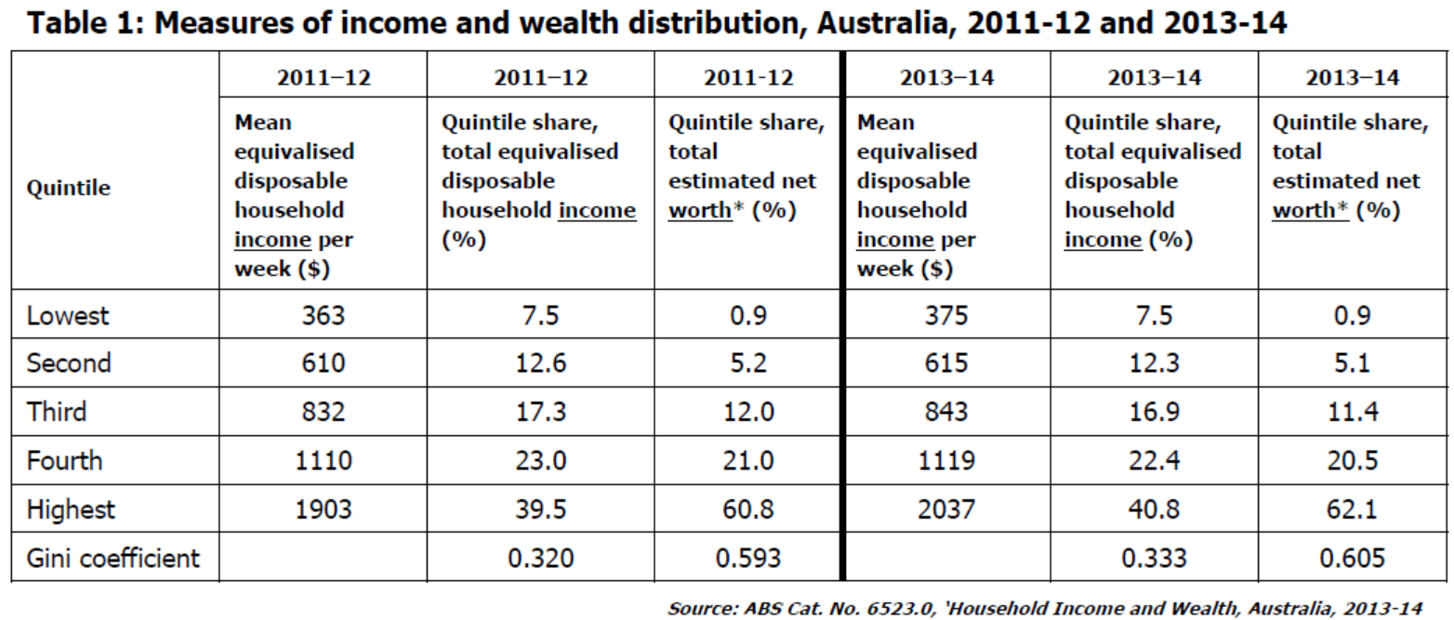

* The ABS uses ‘net worth’ to measure distribution of wealth in Australia. It refers to the value of all assets owned by a household (e.g. property owned outright) minus the value of all liabilities (e.g. debt owed on property).

**‘Reserve Bank governor, Philip Lowe, [said] inequality in Australia is getting worse. …**

**Speaking at an event supporting the Anika Foundation, he said the gap between the rich and poor has widened in recent years, but made the distinction between “wealth” and “income” inequality. … Dr Lowe said income inequality was also rising, but not as badly as wealth inequality. “Income inequality has drifted up a little but not very much,” he said.’**

Extract from: ‘RBA governor says inequality getting worse, contradicting Scott Morrison’, ABC online, 27th July 2017,

http://www.abc.net.au/news/2017-07-26/rba-says-inequality-getting-worse/8746594

**a.** Define ‘income’ and ‘wealth’ and explain how wealth can increase income. 3 marks

_________________________________________________________________________________

_________________________________________________________________________________

_________________________________________________________________________________

_________________________________________________________________________________

_________________________________________________________________________________

_________________________________________________________________________________

_________________________________________________________________________________

_________________________________________________________________________________

_________________________________________________________________________________

_________________________________________________________________________________

_________________________________________________________________________________

**b.** Discuss the RBA Governor’s claim that income inequality ‘has drifted up a little,’ but wealth inequality is much worse. Use data from Table 1 to support your answer. 4 marks

_________________________________________________________________________________

_________________________________________________________________________________

_________________________________________________________________________________

_________________________________________________________________________________

_________________________________________________________________________________

_________________________________________________________________________________

_________________________________________________________________________________

_________________________________________________________________________________

_________________________________________________________________________________

_________________________________________________________________________________

_________________________________________________________________________________

_________________________________________________________________________________

_________________________________________________________________________________

_________________________________________________________________________________

_________________________________________________________________________________

_________________________________________________________________________________

**c.** Explain the likely impact on the distribution of income of the following government budgetary policy decisions: 6 marks

**i.** Increased spending on training and education.

_________________________________________________________________________________

_________________________________________________________________________________

_________________________________________________________________________________

_________________________________________________________________________________

_________________________________________________________________________________

_________________________________________________________________________________

_________________________________________________________________________________

_________________________________________________________________________________

**ii.** An increase in the GST rate from 10% to 12.5%.

_________________________________________________________________________________

_________________________________________________________________________________

_________________________________________________________________________________

_________________________________________________________________________________

_________________________________________________________________________________

_________________________________________________________________________________

_________________________________________________________________________________

_________________________________________________________________________________

**iii.** Application of stricter requirements to welfare payments.

_________________________________________________________________________________

_________________________________________________________________________________

_________________________________________________________________________________

_________________________________________________________________________________

_________________________________________________________________________________

_________________________________________________________________________________

_________________________________________________________________________________

_________________________________________________________________________________

**Question 2 (6 marks)**

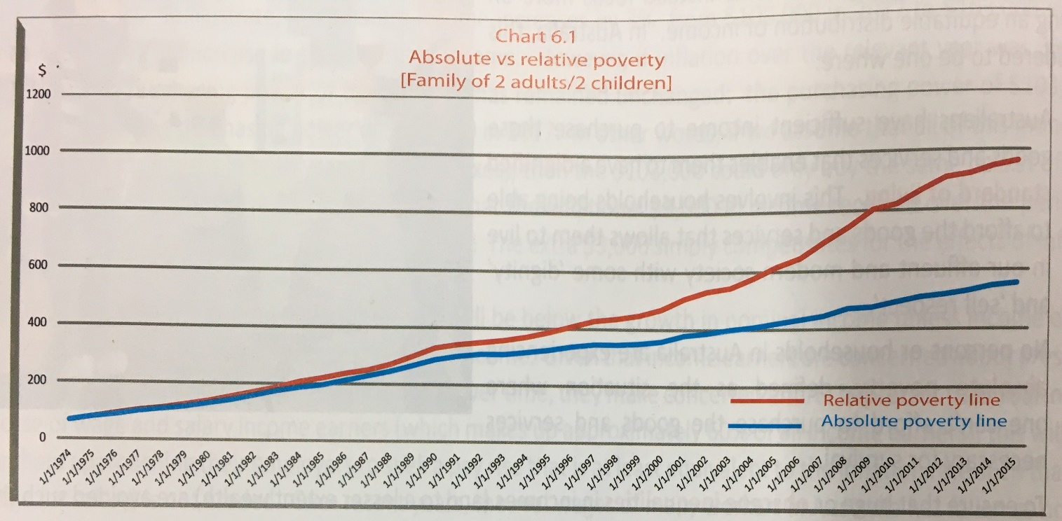

**a.** Explain the difference between ‘absolute’ and ‘relative’ poverty. In your answer, make use of the data presented in the above chart. 3 marks

_________________________________________________________________________________

_________________________________________________________________________________

_________________________________________________________________________________

_________________________________________________________________________________

_________________________________________________________________________________

_________________________________________________________________________________

_________________________________________________________________________________

_________________________________________________________________________________

_________________________________________________________________________________

_________________________________________________________________________________

_________________________________________________________________________________

**b.** Outline how poverty can impact living standards, and explain one action the government can take to help reduce poverty. 3 marks

_________________________________________________________________________________

_________________________________________________________________________________

_________________________________________________________________________________

_________________________________________________________________________________

_________________________________________________________________________________

_________________________________________________________________________________

_________________________________________________________________________________

_________________________________________________________________________________

_________________________________________________________________________________

_________________________________________________________________________________

**Question 3 (3 marks)**

Australia has a ‘progressive income tax system’, where the proportion of income paid in tax increases as income increases.

Explain how a decision by the government to increase the top tax rate paid by high-income earners illustrates the potential conflict between improving efficiency and improving equity in income distribution.

_________________________________________________________________________________

_________________________________________________________________________________

_________________________________________________________________________________

_________________________________________________________________________________

_________________________________________________________________________________

_________________________________________________________________________________

_________________________________________________________________________________

_________________________________________________________________________________

_________________________________________________________________________________

_________________________________________________________________________________

_________________________________________________________________________________

_________________________________________________________________________________

**Question 4 (3 marks)**

The government imposes excise taxes on some goods considered harmful, such as tobacco, alcohol and petrol. For the next four years, the government will increase tobacco excise by

12.5% each September.

Explain how the increase in tobacco excise could improve efficiency in allocation of resources while at the same time reducing equity in the distribution of income.

_________________________________________________________________________________

_________________________________________________________________________________

_________________________________________________________________________________

_________________________________________________________________________________

_________________________________________________________________________________

_________________________________________________________________________________

_________________________________________________________________________________

_________________________________________________________________________________

_________________________________________________________________________________

_________________________________________________________________________________

_________________________________________________________________________________

_________________________________________________________________________________

**END OF SECTION C**

**SECTION D: SHORT ANSWER – GLOBALISATION (10 MARKS)**

Describe the selected global economic issue.

2 marks

_________________________________________________________________________________

_________________________________________________________________________________

_________________________________________________________________________________

_________________________________________________________________________________

_________________________________________________________________________________

Explain **one** economic reason why the global economic issue is of importance to the Australian economy.

2 marks

_________________________________________________________________________________

_________________________________________________________________________________

_________________________________________________________________________________

_________________________________________________________________________________

_________________________________________________________________________________

Evaluate the costs and benefits associated with action undertaken by relevant stakeholders to address the selected global issue.

6 marks

_________________________________________________________________________________

_________________________________________________________________________________

_________________________________________________________________________________

_________________________________________________________________________________

_________________________________________________________________________________

_________________________________________________________________________________

_________________________________________________________________________________

_________________________________________________________________________________

_________________________________________________________________________________

_________________________________________________________________________________

_________________________________________________________________________________

_________________________________________________________________________________

_________________________________________________________________________________

_________________________________________________________________________________

_________________________________________________________________________________

_________________________________________________________________________________

_________________________________________________________________________________

_________________________________________________________________________________

_________________________________________________________________________________

_________________________________________________________________________________

_________________________________________________________________________________

_________________________________________________________________________________